**TUGAS 7 PKPL PELAKSANAAN UJI PL**

Yurhiko Arshal Fauzan  
2000018246/B

**Skenario Uji PL**

Halaman pendaftaran website rental mobil docar.co.id (mengambil website yang mirip dengan dokumen kontrak karena pada website yang terdapat pada dokumen kontrak tidak memiliki form inputan)

Home Page Website

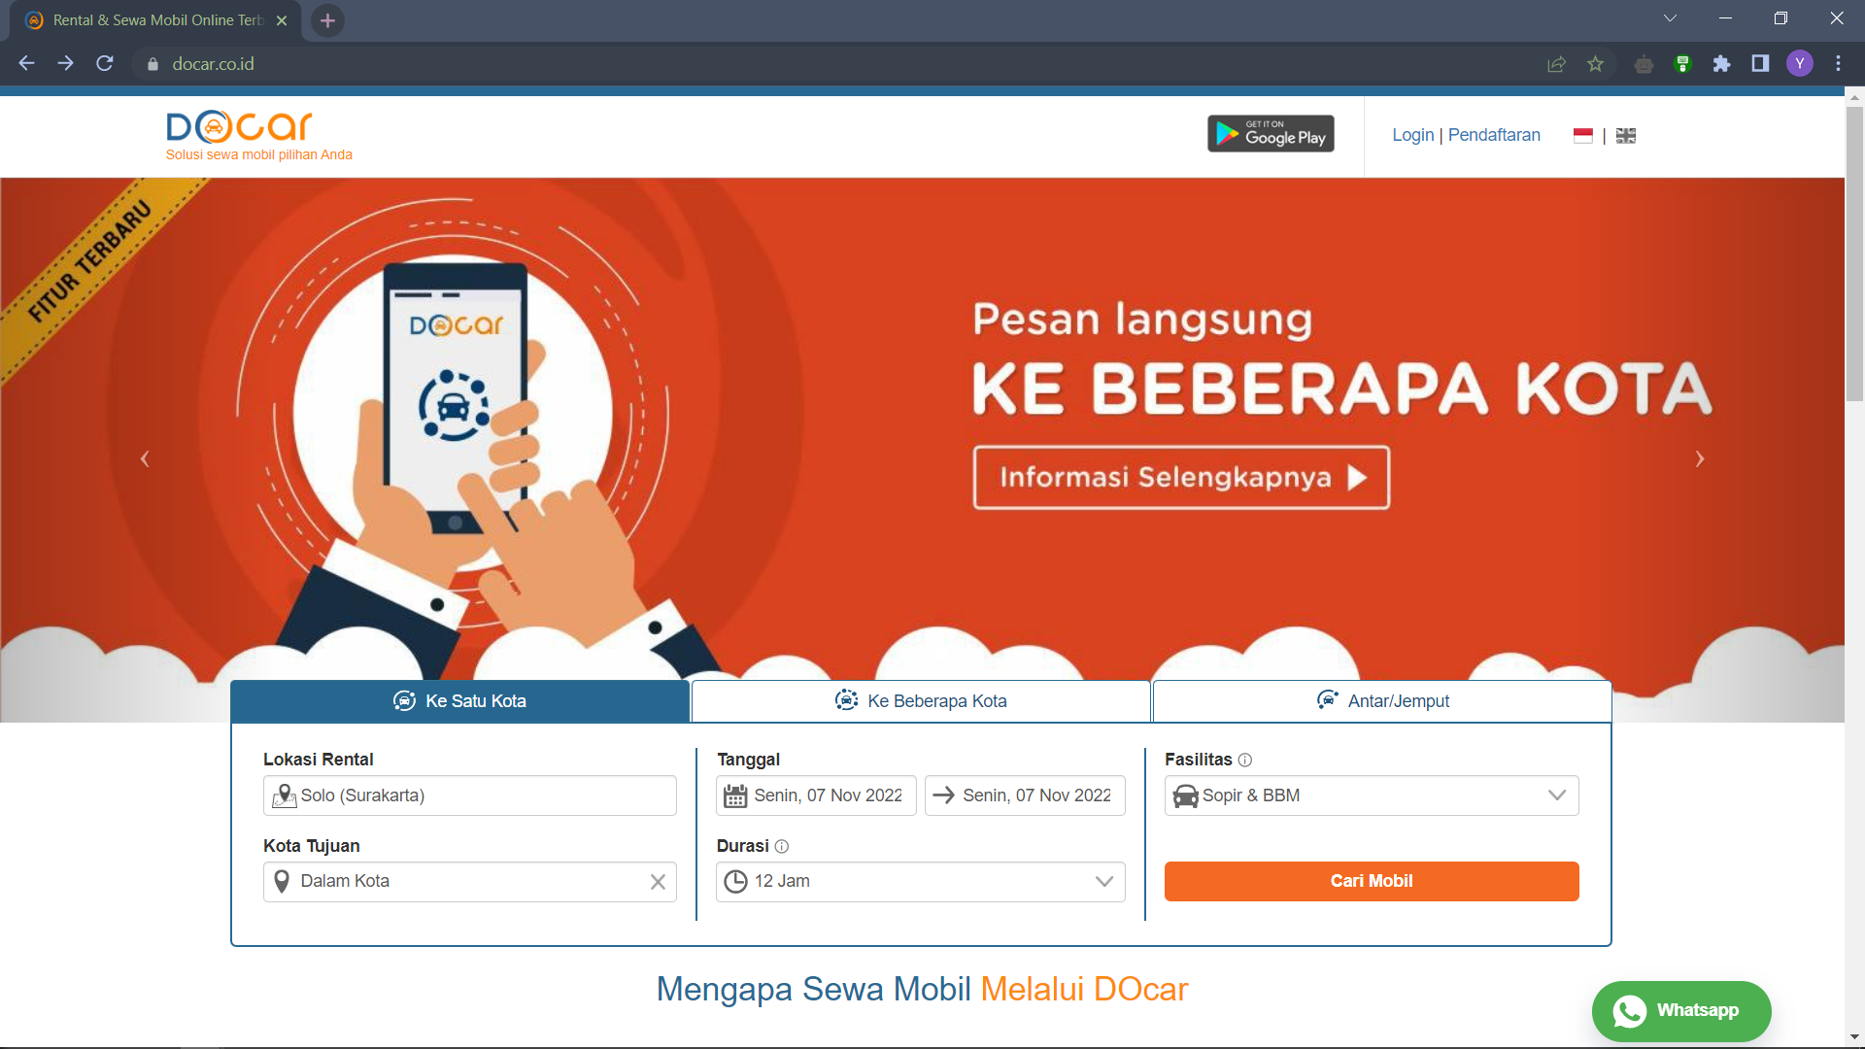

Registration Page Website

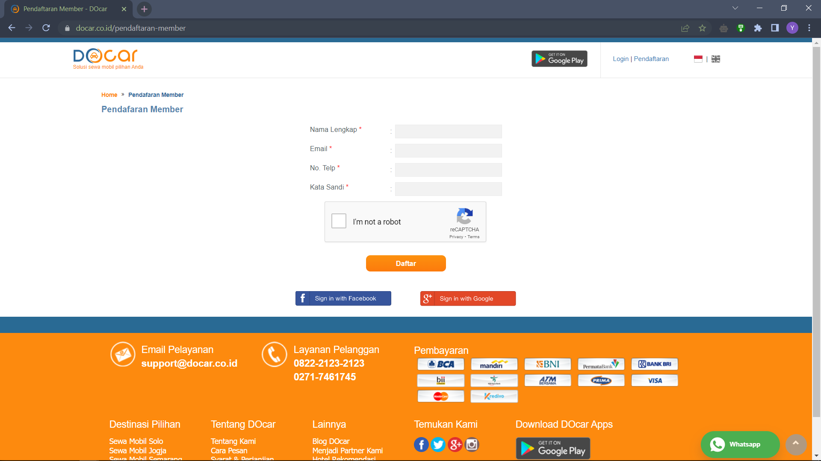

Login Page Website

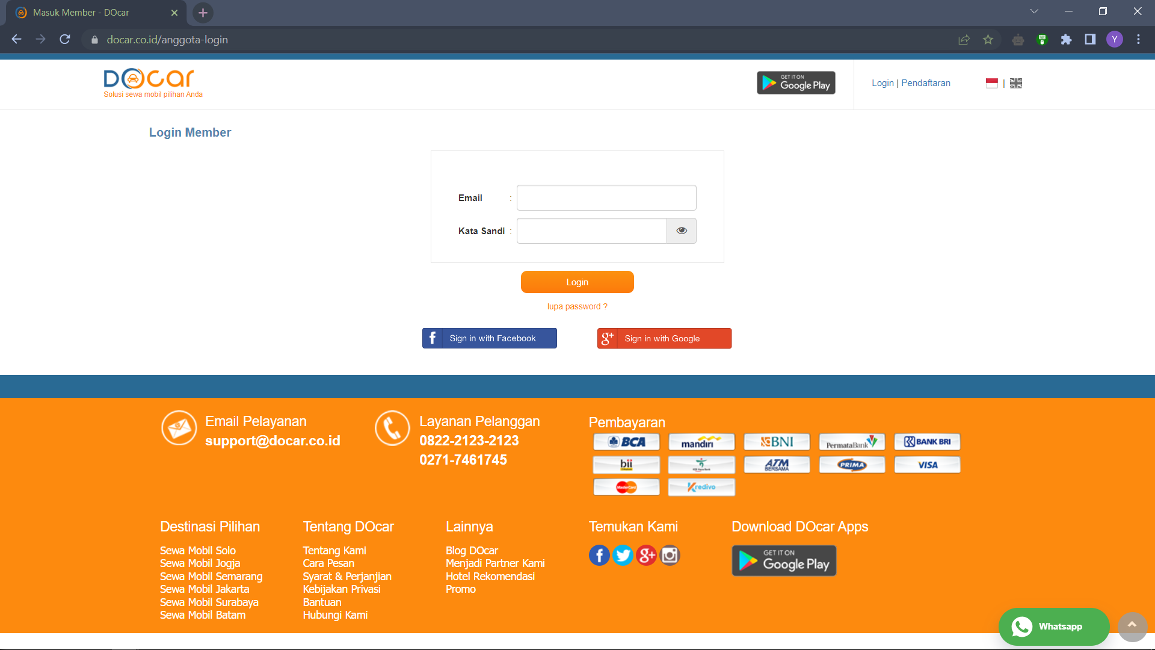

Order Page Website

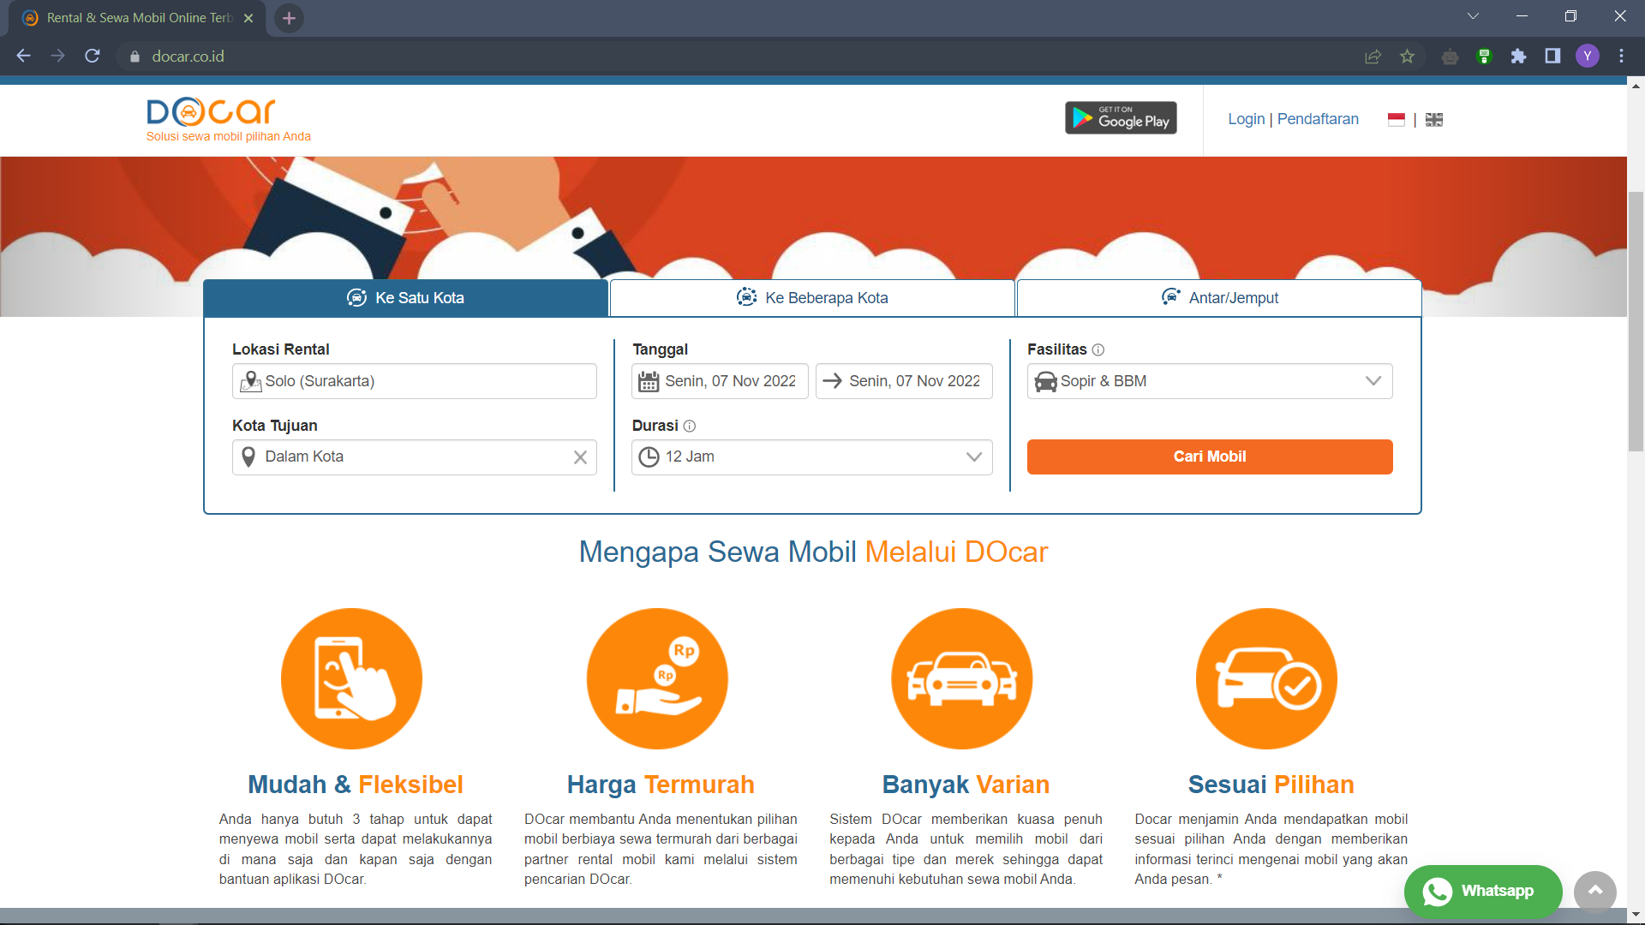

Pembuatan Skenario Uji PL

|  |  |  |  |
| --- | --- | --- | --- |
| Project Name : docar.co.id | | | Reviewed By : Yurhiko Arshal Fauzan |
| Module Name : User | | | Reviewed Date : 6 November 2022 |
| Document : | | | Approved By : |
| Author : PT Docar Rental Indonesia | | | Approved Date : |
| Created Date : | | |  |
| Scenario ID | Module | Requirement | Test Scenario |
| TS001 | User | R1.0 Docar Home Page | Check Launching Website |
| TS002 | User | R1.0 Docar Home Page | Check Navigation of Home Page |
| TS003 | User | R2.0 Docar Registration Page | Check User Registration |
| TS004 | User | R2.0 Docar Registration Page | Check Captcha |
| TS005 | User | R3.0 Docar Login Page | Check User Login |
| TS006 | User | R4.0 Docar Order Page | Check Navigation of Order Page |

**Pelaksanaan Uji PL**

Form Register



Menggunakan metode Decision Table

|  |  |  |  |  |  |  |  |  |  |
| --- | --- | --- | --- | --- | --- | --- | --- | --- | --- |
| Inputs | TC1 | TC2 | TC3 | TC4 | TC5 | TC6 | TC7 | TC8 | TC9 |
| Nama Lengkap | Yes | No | Yes | Yes | Yes | Yes | No | No | No |
| Email | Yes | Yes | No | Yes | Yes | Yes | No | Yes | Yes |
| No Telp | Yes | Yes | Yes | No | Yes | Yes | Yes | No | Yes |
| Kata Sandi | Yes | Yes | Yes | Yes | No | Yes | Yes | Yes | No |
| Captcha | Yes | Yes | Yes | Yes | Yes | No | Yes | Yes | Yes |
| Expexted Result |  | Error | Error | Error | Error | Error | Error | Error | Error |

|  |  |  |  |  |  |  |  |  |  |
| --- | --- | --- | --- | --- | --- | --- | --- | --- | --- |
| Inputs | TC10 | TC11 | TC12 | TC13 | TC14 | TC15 | TC16 | TC17 | TC18 |
| Nama Lengkap | No | Yes | Yes | Yes | Yes | Yes | Yes | No | No |
| Email | Yes | No | No | No | Yes | Yes | Yes | No | No |
| No Telp | Yes | No | Yes | Yes | No | No | Yes | No | Yes |
| Kata Sandi | Yes | Yes | No | Yes | No | Yes | No | Yes | No |
| Captcha | No | Yes | Yes | No | Yes | No | No | Yes | Yes |
| Expexted Result | Error | Error | Error | Error | Error | Error | Error | Error | Error |
| Inputs | TC19 | TC20 | TC21 | TC22 | TC23 | TC24 | TC25 | TC26 | TC27 |
| Nama Lengkap | No | No | No | No | Yes | Yes | Yes | Yes | No |
| Email | No | Yes | Yes | Yes | No | No | No | Yes | No |
| No Telp | Yes | No | No | Yes | No | No | Yes | No | No |
| Kata Sandi | Yes | No | Yes | No | No | Yes | No | No | No |
| Captcha | No | Yes | No | No | Yes | No | No | No | Yes |
| Expexted Result | Error | Error | Error | Error | Error | Error | Error | Error | Error |

|  |  |  |  |  |  |
| --- | --- | --- | --- | --- | --- |
| Inputs | TC28 | TC29 | TC30 | TC31 | TC32 |
| Nama Lengkap | No | No | No | Yes | No |
| Email | No | No | Yes | No | No |
| No Telp | No | Yes | No | No | No |
| Kata Sandi | Yes | No | No | No | No |
| Captcha | No | No | No | No | No |
| Expexted Result | Error | Error | Error | Error | Error |

Form Login



|  |  |  |  |  |  |  |  |  |
| --- | --- | --- | --- | --- | --- | --- | --- | --- |
| Inputs | TC1 | TC2 | TC3 | TC4 | TC5 | TC6 | TC7 | TC8 |
| Email | Yes | No | Yes | Yes | No | Yes | No | No |
| Kata Sandi | Yes | Yes | No | Yes | No | No | Yes | No |
| Login | Yes | Yes | Yes | No | Yes | No | No | No |
| Expected Result |  | Error | Error | Error | Error | Error | Error | Error |

Kesimpulan : Jika semua field pada form login dan register diisi maka akan berhasil login/registrasi. Tapi jika terdapat salah satu field yang kosong atau tidak diisi maka akan menampilkan output error.